# **Jmeter Timers: Constant, Gaussian Random, Uniform [Example]**

## **What are Timers?**

By default, JMeter sends the request **without pausing** between each request. In that case, JMeter could **overwhelm** your test server by making too many requests in a short amount of times.

Let imagine that you send **thousands** request to a web server under test in a few seconds. This is what happens!



Timers allow JMeter to **delay** between each request which a thread makes. A timer can solve the server **overload** problem.

Also,**in real life visitors do not arrive at a website all at the same time, but at different time intervals. So Timer will help mimic the real-time behavior.**

Following are some **common** types of a timer in JMeter

## **Constant Timer**

Constant timer delays each user request for the **same** amount of time.

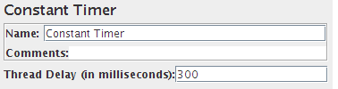

## **Gaussian Random Timer**

[Gaussian](http://hyperphysics.phy-astr.gsu.edu/hbase/math/gaufcn.html) random timer delays each user request for a **random** amount of time.

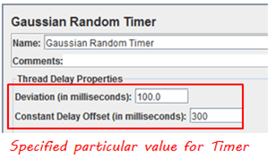

### **Parameters**

|  |  |
| --- | --- |
| **Attribute** | **Description** |
| Name | Descriptive name for this timer that is shown in the tree |
| Deviations (milliseconds) | A **parameter** of Gaussian Distribution Function |
| Constant Delay Offset (milliseconds) | **Additional** value in milliseconds |

So the total delay is described as below figure:

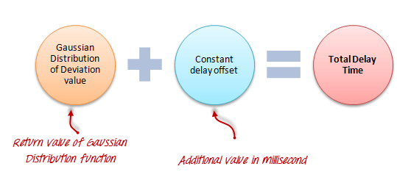

## **Uniform Random Timer**

Uniform random timer delays each user request for a random amount of time.

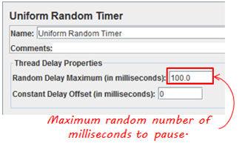

### **Parameters**

|  |  |
| --- | --- |
| **Attribute** | **Description** |
| Name | Descriptive name for this timer that is shown in the tree |
| Random Delay Maximum | Maximum random number of milliseconds to delay. |
| Constant Delay Offset (milliseconds) | **Additional** value in milliseconds |

**The total delay is the sum of the random value and the offset value.**

## **BeanShell Timer**

The [BeanShell](http://www.beanshell.org/) Timer can be used to **generate** a delay time between each user request.

## **BSF Timer**

The BSF Timer can be used to generate a delay between each user request using a [BSF](https://en.wikipedia.org/wiki/Bean_Scripting_Framework) scripting language.

## **JSR223 Timer**

The JSR223 Timer can be used to generate a delay between each user request using a [JSR223](https://en.wikipedia.org/wiki/JSR223) scripting language

## **How to Use Constant Timer**

In this example, you will use **Constant Timer** to set **a fixed delay** between user requests to google.com.

Let start with a simple test script

1. JMeter creates **one** user request to [http://www.google.com](https://www.google.com/) **100** times
2. **Delay** between each user request is **5000** ms

Here is the **roadmap**for this practical example:

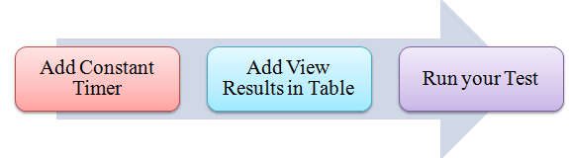

## **Pre-condition**

We **re-use** the Step 1 and Step 2 in tutorial [JMeter Performance Testing](https://www.guru99.com/jmeter-performance-testing.html).

### **Step 1) Add Thread Group**

Right click on the[Test Plan](https://www.guru99.com/what-everybody-ought-to-know-about-test-planing.html)and add a new thread group: **Add**-> **Threads (Users)** ->**Thread Group**

In Thread Group control panel, enter Thread Properties as following

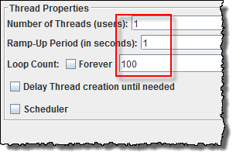

This setting lets JMeter create **one** user request to [http://www.google.com](https://www.google.com/) in **100** times

### **Step 2) Add JMeter elements**

* Add HTTP request default
* Add HTTP request

### **Step 3) Add Constant Timer**

Right-click **Thread Group -> Timer -> Constant Timer**

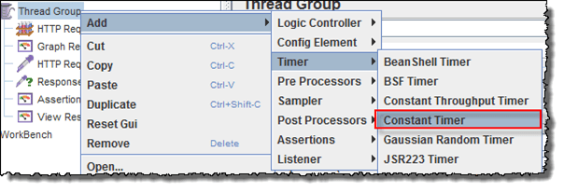

Configuring Thread Delay of 5000 milliseconds

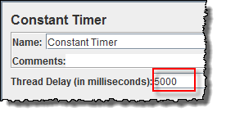

### **Step 4) Add View Results in Table**

View Results in Table displays the test result in table format.

Right click **Add -> Listener ->View Result in Table**

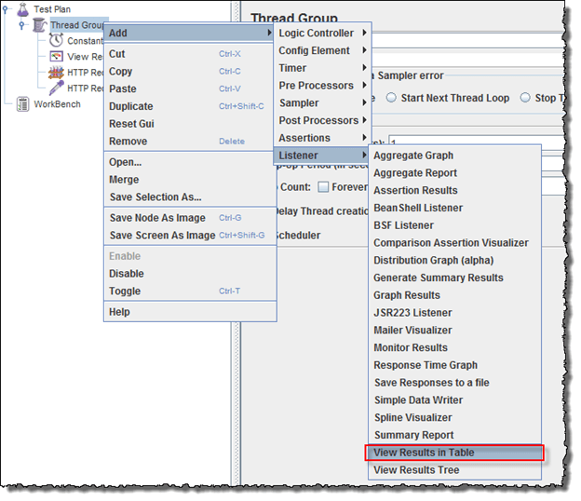

View Results in Table displays as below figure

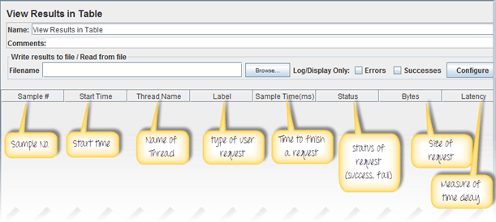

### **Step 5) Run your test**

When you ready to run a test, click **the Run** button on the menu bar, or short key **Ctrl+R**

This is the result of this test

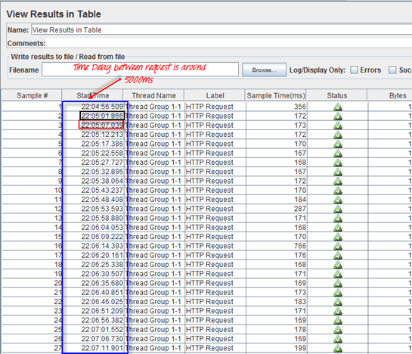

For example, in the above figure, let analyze the **Sample 2**

* **Start time**is 22:05:01.866
* **Sample Time** of Sample 2 is 172 ms
* **Constant Timer**: 5000 ms (as configured)
* **End Time** of this sample is = 22:05:01.866 + 172 + 5000 = 22:05:07.038

So the Sample 3 should start at the time is **22:05:07.039**( As shown in the above figure)

The **delay** of each sample is **5000** ms

If you change the Constant Timer is **zero**, you will see the result is changed

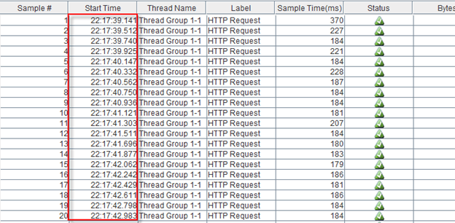

Let analyze the **Sample 1**

* **Start time**is 22:17:39.141
* **Sample Time** of Sample 2 is 370 ms
* **Constant Timer** : 0 ms (as configured)
* **End Time** of this sample is = 22:17:39.141+ 370 + 0 = 22:17:39.511

So the **Sample 2** should start at the time is **22:17:39.512** (Shown in the above figure)

## **Troubleshooting**

If you face the issue while running the above scenario … do the following

1. Check whether you are connecting to the internet via a proxy. If yes, remove the proxy.
2. Open a new instance of JMeter
3. Open the [TimerTestPlan.jmx](https://drive.google.com/uc?export=download&id=0B_vqvT0ovzHcUjJ5Vm1rN0g1ZlU) in Jmeter
4. Double Click on Thread Group -> View Result in Table
5. Run the Test